Post Graduate Certificate Leadership and Management: Homelessness and Housing

COURSE GUIDE 2019/20 v5

London South Bank University
103 Borough Road
London SE1 0AA

© Copyright London South Bank University February 2019

Post Graduate Certificate Leadership and Management: Homelessness and Housing

1. About London South Bank University

London South Bank University is a dynamic institution, with some 25,000 students: undergraduate, postgraduate, both full and part-time and research scholars who are working towards MPhil and PhD degrees. By joining the university you are entering an academic community which has a new and energetic approach to its students and scholars based in the heart of London, just a mile from the South Bank arts complex, Westminster and the City of London.

2. Introduction

This course was developed by the School of Business in collaboration with the London Housing Foundation, who are sponsoring the course. Appendix 1 sets out key information about the London Housing Foundation and students are asked to refer to this as it is critical to the background and ethos of the programme.

The programme aims to develop leadership and management skills for current managers and future leaders of organisations in this area of work.

The course is primarily designed for appropriately experienced and qualified staff in the homelessness and allied sectors. Participation in the course also enables graduates to take advantage of LHF’s Professional Development Programme including appropriate one day training courses and the opportunity for an international study trip.

The course will run from September 2019 until June 2020 on a part time basis on 8 two-day blocks; Thursday and Fridays. There will be an initial residential from Tuesday 1 to Thursday 3 October 2019.

3. Programme Aims

The Post Graduate Certificate in Management and Leadership: Housing and Homelessness aims to:

- Reflect changes in the operating environment, service provision and Government policy and to develop a critical, enquiring and analytical approach to the study of these changes
- Contribute to course participants on-going CPD and life-long learning as well as to employers’ commitment to staff training and development
- Develop and enhance the skills, knowledge, academic theory and current practice to manage in a changing sector environment
- Reflect government policy to provide efficient and effective housing and homelessness strategies run by proficient and effective managers and potential leaders
- Reflect changes in styles of management theory and practice, recognising the changes in these homelessness and allied sectors and the requirements of managers for the skills and knowledge to manage cross-sectorally as well as inter-sectorally
- Develop professional and personal confidence to manage and to progress professionally

4. Entry Requirements

The admission of students to a programme of study are governed by the normal entry requirements for postgraduate management awards at London South Bank University and by the requirements specified below.

Applicants will normally require:

a) A degree or equivalent qualification together with appropriate senior work experience in a relevant setting.
or

b) A professional qualification together with appropriate senior work experience in a relevant setting.

or

c) Relevant senior sector experience, recognised as enabling the applicant to join a course at this level,

The relevance of an applicant’s experience would normally be discussed at interview

5. Programme Sequence

The Programme is a part time course commencing in September 2019 with classes ending in June 2020. ROOMS WILL BE ANNOUNCED NEARER THE START DATES.

There are four teaching modules, two in the first semester and two in the second semester as described below.

First Semester 2019

Enrolment: Enrolment to the course will take place in September at LSBU.

Residential: An initial residential from Tuesday 1 to Thursday 3 October at Cumberland Lodge, Windsor Great Park. There will be a small group task following which group members will make a presentation. This will be “formatively” assessed. (This formative assignment does not count towards the final award but is an opportunity to receive feedback on a piece of group work.)

Induction session: At LSBU a Thursday afternoon in September from 2.00 till 5.00. This will include a visit to the library and a tour of the campus.
Library and Study Skills Sessions: To support participants studying at postgraduate level for the first time, or to provide revision for those who already have, four additional sessions are offered. Two will take place in the library. The dates for these sessions will be announced nearer the time.
Module 1: Leadership and Management:. Will run on a day and a half over four two-day Blocks – Thursdays 10.00 till 6.00 and Fridays 9.00 till 5.00. Please note the different timings for each day. This is to allow a little more travelling time at the start and finish of the block.
The dates are:
Block 1: Thursday 10 and Friday 11 October 2019
Block 2: Thursday 14 and Friday 15 November 2019
Block 3: Thursday 12 and Friday 13 December 2019
Block 4: Thursday 17 and Friday 18 January 2020
The module will be led by Chuck Tjok-A-Tam, supported by Andrew Summers
Module 2: Finance for Non-Finance Managers*: Half a day on each of the above four blocks. The module will be led by Dr Charles Jardine
* Module title subject to internal LSBU approval

Second Semester 2020

Module 3: Organisational Development*: Will run on a day and a half over four two-day Blocks – Thursdays 10.00 till 6.00 and Fridays 9.00 till 5.00. Please note the different timings for each day. This is to allow a little more travelling time at the start and finish of the block.
* Module title subject to internal LSBU approval
The PROVISIONAL dates are:
Block 5: Thursday 6 and Friday 7 February 2020
Block 6: Thursday 12 and Friday 13 March 2020
Block 7: Thursday 2 and Friday 3 April
Block 8: Thursday 7 and Friday 8 May 2020
There will also be a final full day on Friday 15 May when participants will present an outline of their coursework to assessors and classmates.
The module will be led by Dr Jan Rae, supported by Andrew Summers
Module 4: Governance, Risk and Ethics:. Half a day on each of the above four blocks. The module will be led by Dr Charles Jardine
* Module title subject to internal LSBU approval
There is an Easter Break from Monday 6 to Friday 24 April inclusive and a “Recess Week” from Monday 25 until Friday 29 May. There are no classes during these weeks although the university and the library will be open.

6. Course Structure

The course comprises the following taught Modules:-

Leadership and Management (20 Credits)
We will examine the different concepts of leadership and management focussing on what might be considered the more appropriate styles in the homelessness and housing context. It will include value-based leadership and change management. There will be opportunities to evaluate your own individual and organisational competences and for skill development using in-depth reflections.

Finance for Non-Finance Managers*: (10 credits)
This Module is designed to provide students with knowledge of basic concepts and practices in accounting, an understanding of accounting requirements in not-for-profit organisations and an appreciation of good practice in financial reporting. It will introduce key elements of project accounting, including an understanding of basic costing approaches as well as understanding the theory and basis of management accounting, including budgeting and reporting.

Organisational Development* (20 Credits)
This module will provide an overview of theories, techniques and knowledge in the area of Organisational Behaviour and People Management. It adopts a critical and comparative perspective of the issues and implications which relate to managing people. Underpinned by Organisational Behaviour, Management and HRM research, the module aims to help students develop an understanding of people management issues in relation to working with both paid or unpaid staff. There will be ample scope to analyse your own organisation’s practices in light of the theory.
Governance, Risk and Ethics* (10 Credits)
The purpose of this module is to enable participants to reflect on and understand the role of governance in ensuring accountability within their organisations. This module will introduce concepts and theories of governance together with practical tools to facilitate and enable appropriate accountability.

* Module title subject to internal LSBU approval

- Module Assessments

Leadership and Management
100% Coursework with 2 Elements as follows:
Element 1 (40% weighting) –Two examples of high-level reflections on your leadership or managerial performance.
Element 2 (60% weighting) – An individual written assignment, applying relevant theoretical concepts to your organisation.

Finance for Non-Finance Managers*:

100% Coursework with one Element
Assessment will be based on a Case Study which will be worked on during the module
Organisational Development*
100% Coursework but with 2 Elements as follows:

Element 1: (80% weighting) Assignment based in students’ own organisation
Element 2: (20% weighting) Individual presentation on an outline of, and recommendations from, Element 1. (This to take place on 24 May 2020, before the submission of Element 1 in June 2020, to enable feedback to be taken into account.)

Governance, Risk and Ethics*

100% Coursework
The Coursework will be an individual written assignment.

Overall
The weighted pass mark across the modules is 50%. Where there are multiple assessments, a 40% minimum pass on each element is a necessary condition of an overall pass. It is necessary to pass all the modules to be awarded the Postgraduate Certificate.

8. Assessment regulations

Module submission assessments dates will be set out in the Module Guides and via the in-house Moodle web site.

Regulations for assessment and progression will follow the LSBU Academic Regulations for Taught Programmes:
http://www.lsbu.ac.uk/current.student/downloads/Academic RegsTaughtProgs.pdf

9. Virtual Learning Environment (VLE)

Email
All students on enrolment are given an LSBU email account, and students can access this account on or off campus. All contact with students on the course will be via their LSBU email address.

Virtual Learning Environment
Students on and off campus will have access to, a virtual learning environment which enables students and tutors to share learning resources, communicate, collaborate and support progress. It allows students and tutors to have flexible access as it can be used on and off campus and at any time of the day (or night!). As well as providing support for individual modules, the site will contain a virtual notice board which allow Course Directors and Tutors to put up information relating to the course as and when it becomes available. It will be recommended that students check the VLE site on a regular basis.

11. Information on How to Apply and Fees

Recruitment Process and Fees:

LHF leads on recruitment for this programme. Invitations for Expressions of Interest will be sent out by LHF. Suitable candidates will then be invited by LHF to submit a formal online UCAS application by according to the instructions below and the recruitment timetable in Section 13.

LHF contracts with LSBU for this course. Fees for this course are currently capped at £2700 per student with LHF meeting 50% of the cost. The cost per student is therefore capped currently at £1350. LHF will invoice organisations who have candidates successfully enrolled on the programme for their contribution shortly after the start of the course.

Formal Applications:

To make an application, follow the instructions below; (Where it says “Year 1 Full time” it should read “Part Time”)

UK ONLINE APPLICATION SYSTEM
Instructions for Prospective Students
Making your application
To Create and account you will need to go this URL (and bookmark):
http://www.lsbu.ac.uk/application-system

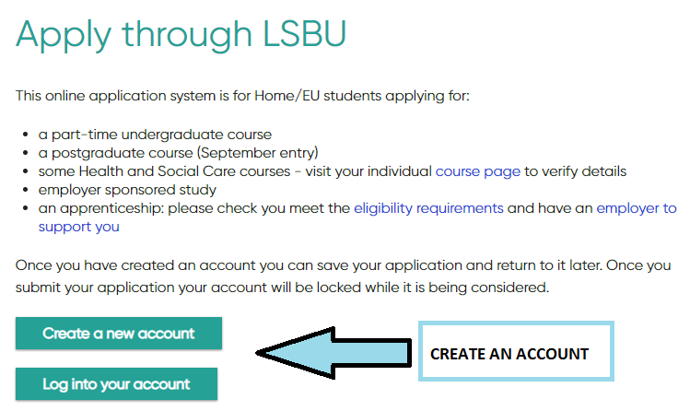

Once you have created your account, you should be presented with the following

Select the following option:

Search for the Course in question
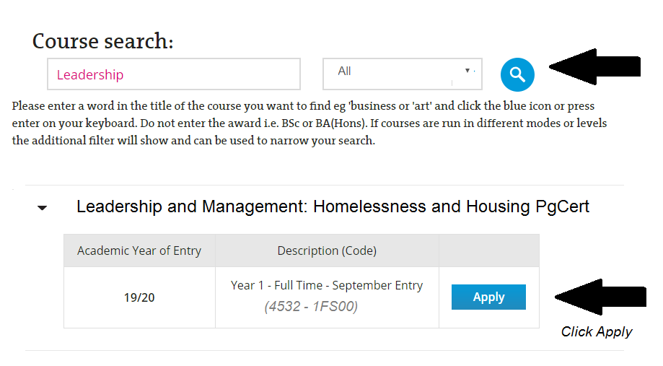

Once you click apply, you will be presented with the application where you will need to fill out all the relevant sections.
Personal Details
Qualifications
Education/Employment Details
Personal Statement, Reference and CV & Miscellaneous documents (Upload additional information/Certification

12. Course Contacts

Chuck Tjok-a-Tam – Course Director
Tel: (44) 020 7815 7715
Email: tjokatac@lsbu.ac.uk

Paul Charlett
Course Administrator
Tel: (44) 020 7815 8211
Email: charletp@lsbu.ac.uk

13. Recruitment Timetable

8 February 2019 | EOIs sent out to interested parties by LHF | This includes appropriate organisations on LHF’s database, and those already having expressed an interest, local authorities and MHCLG
14 March 2019, noon | All EOIs to be received by LHF | If there is any reason why an EOI cannot be submitted by the deadline, this should be notified to LHF in advance
18 March 2019 | LSBU open for formal online applications | Instructions on how to use the system will be sent to those invited to apply by LSBU
23 April 2019, 5.00pm | Deadline for formal online applications | If there is any reason why an application cannot be submitted by the deadline, this should be notified to LHF in advance
w/c 6 May 2019 | LSBU/LHF review of applications | Applicants to be invited for interview will be notified by LSBU Admissions
w/c 20 May/and 3 June 2019 | Interviews to be held at LSBU | Applicants should make a note in their diaries of potential interview dates
w/c 10 June 2019 | Formal offers and/or rejections will be sent out by LSBU | All successful applicants must accept the offer. Instructions will be sent out
12 and 19 September 2019 | LSBU Enrolment/Induction | To be held at LSBU
1-3 October 2019 | Introductory Residential at Cumberland Lodge, Windsor Great Park | A chance to meet other course participants and key individuals from LSBU and LHF
10 October 2019 | Academic programme commences | Provisional dates for all modules included in the Course Guide

Appendix 1: Key Information from London Housing Foundation

What We Do

LHF’s primary aim is to reduce street homelessness amongst single people. We do this by supporting the work of agencies that provide services to single homeless people or to those who are in imminent danger of homelessness.

We do not directly provide any services ourselves to homeless people but we run programmes and provide grants to help those that do. As our name suggests we focus the majority of our efforts on agencies working in London but we do from time to time support agencies outside London. We have funded some projects in Eastern Europe when we have seen an overwhelming case for humanitarian assistance for single homeless people.

History of the PG Certificate in Leadership and Management: Homelessness and Housing

In 2014, LHF prioritised a need for capacity building within the sector to ensure that organisations and individuals working towards the same ends of combatting homelessness had the necessary people with the necessary skills to work towards this shared vision. Following discussions with LSBU, we embarked on the first programme of the PG Certificate in January 2015 and have just commenced our fifth year of the programme, starting in January 2019.

In 2017 we broadened our scope for the programme to include local authorities and central government.

Following feedback from students, we have now managed to re-align the timing of the programme to fit with the academic year, rather than the calendar year. We are therefore inviting applications for the sixth year of the programme to commence in September 2019.

LHF’s Current Priorities

Please have a look at LHF’s website to find out more about the work that we support that includes the Leadership and Management Programme with LSBU, the London Homelessness Awards, responsive grants, homelessness in other countries, especially as they may impact on the UK. http://lhf.org.uk/

International Aspect
LHF believes strongly that homelessness agencies working in London and the UK can learn from other agencies carrying out similar work abroad. This learning can take the form of both seeing how others deliver services, but also in Europe and particularly the EU, understanding how local economic and social conditions can impact directly on the demand for services from the agencies in London itself.

LHF has had a close partnership with Depaul International for 8 years. This has allowed us to both support Depaul’s international humanitarian work with homeless people in Eastern Europe and through this collaboration to better understand the links between homelessness in London and other major European cities.

For many years LHF has provided bursaries for individuals working in London who wish to visit agencies abroad and we have also organised reciprocal trips to allow foreign agencies to see the work carried out in London. Recently we have concentrated our funding on bursaries in support of our Leadership Programme that offers all graduates the opportunity to travel and see how other organisations tackle homelessness in their countries.

The current focus of the bursaries we offer to Leadership Programme graduates is the impacts of migration on homelessness in European cities.

We want to give participants on the LHF/LSBU programme the opportunity to develop their skills and broaden their horizons by affording everyone the same opportunity to explore what is happening in other countries. We also offer other opportunities to graduates through our Professional Development Programme.

LHF Contacts:

Margaret Malcolm
LHF Course Project Director
Tel: +44 7799 066149
Email: margaret.malcolm@lhf.org.uk

Cassandra Karanjia
LHF Programme Manager
Tel: +44 20 7934 0177
Email: cassandra.karanjia@lhf.org.uk

